E-commerce Application

I WILL PROVIDE YOU WITH SCREEN SHOTS TO HELP YOU MOVE THROUGH THE PROJECT

Introduction
Welcome to the user documentation for our e-commerce application. This will be a guide for you to successfully run the project on ECLIPSE using Tomcat server and MYSQL WORKBENCH.

- System requirements
- Operating system should be windows 10, macOS, or Linux.
- Java Development Kit (JDK) version 8 or later.
- Apache Tomcat if not then any other compatible servlet container (eg GlassFish).
- MYSQL database server or Microsoft SSQL Server.

- Installation instructions
- Follow these steps to install the e-commerce application.
- Download the application package.
- Extract the content of the package to a desired location on your computer.

- Running the application
- Start your database server (MYSQL or SQL server)
- Deploy the application WAR file to your servlet container (e.g. Apache Tomcat).
- Start the servlet container.
- After running the servlet you should be taken to the home page of the e-commerce.

- What to do on the Home page
- You will see a Nav bar where you will see REGISTER.
- If you wish to register fill in the details Those details that you fill in will appear in the database, under the user table.
- If you DO NOT wish to register I would like you to click on the log in page and click LOGIN AS CUSTOMER enter these details username= demo and password= demo.
- If you wish to log in as ADMIN then click login as ADMIN enter these details username=Admin password= Admin.
- REMEMBER AVAILABE STOCK OF BOOKS WILL ONLY BE SEEN IF YOU ARE LOGGED IN AS USER OR ADMIN

- What to do when logged in as USER
- When logged in as user click on available books in the Nav bar.
- Here you will be able to see the book title the Author of the book the Quantity of the books and the price of the books.
- When selecting book just click on Add to Cart.
- When done selecting the books you would like to purchase either click on the cart option on the Nav bar or Proceed to checkout, these will take you to the cart.
- In the cart you can see the books you have selected and if you wish to remove just click on MINUS sign if u wish to add the quantity of the book click on the PLUS sign.
- Then click on Proceed to pay.
- Here I would like you to enter RANDOM details please don’t add correct.
- Once details filled click on Pay & Place order like that your order has been placed.
- Then you can LOG OUT by clicking on the it in the Nav bar.
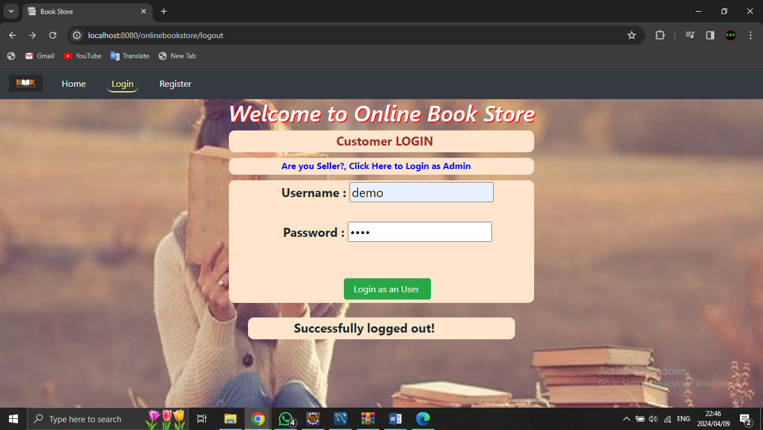
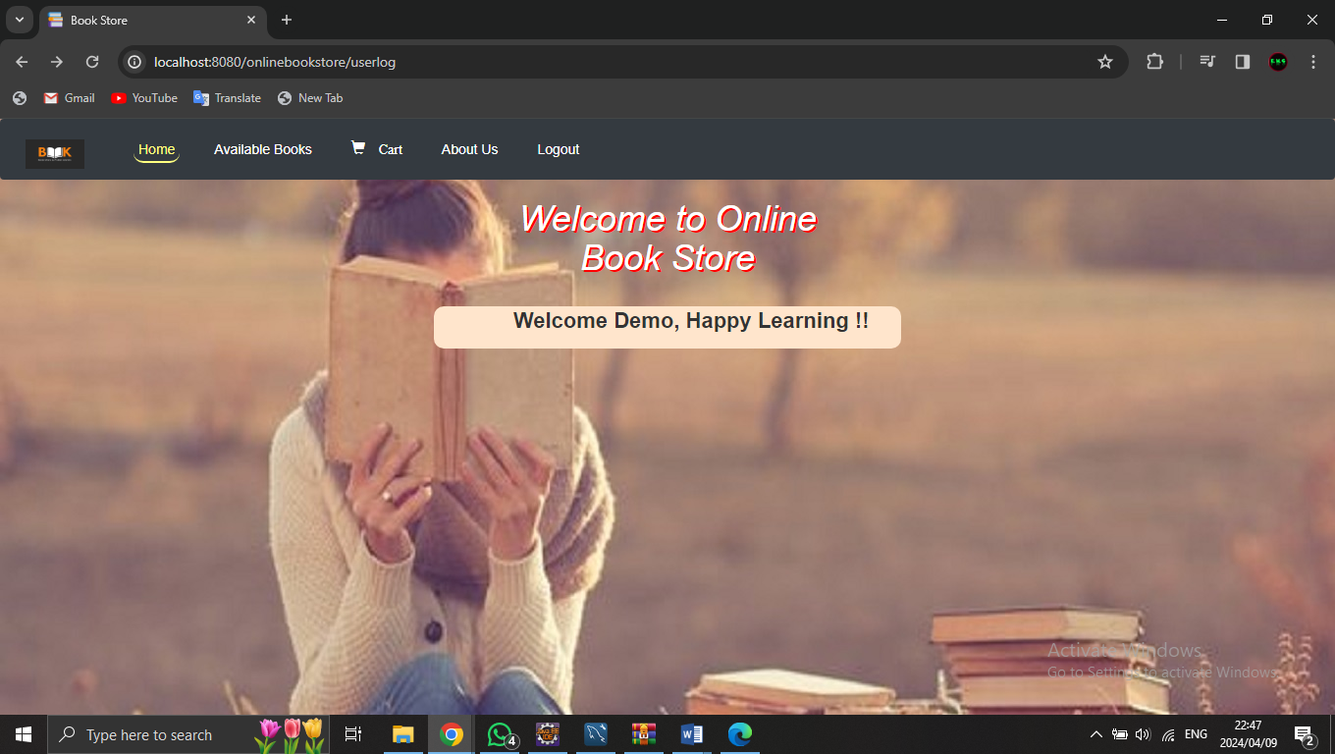
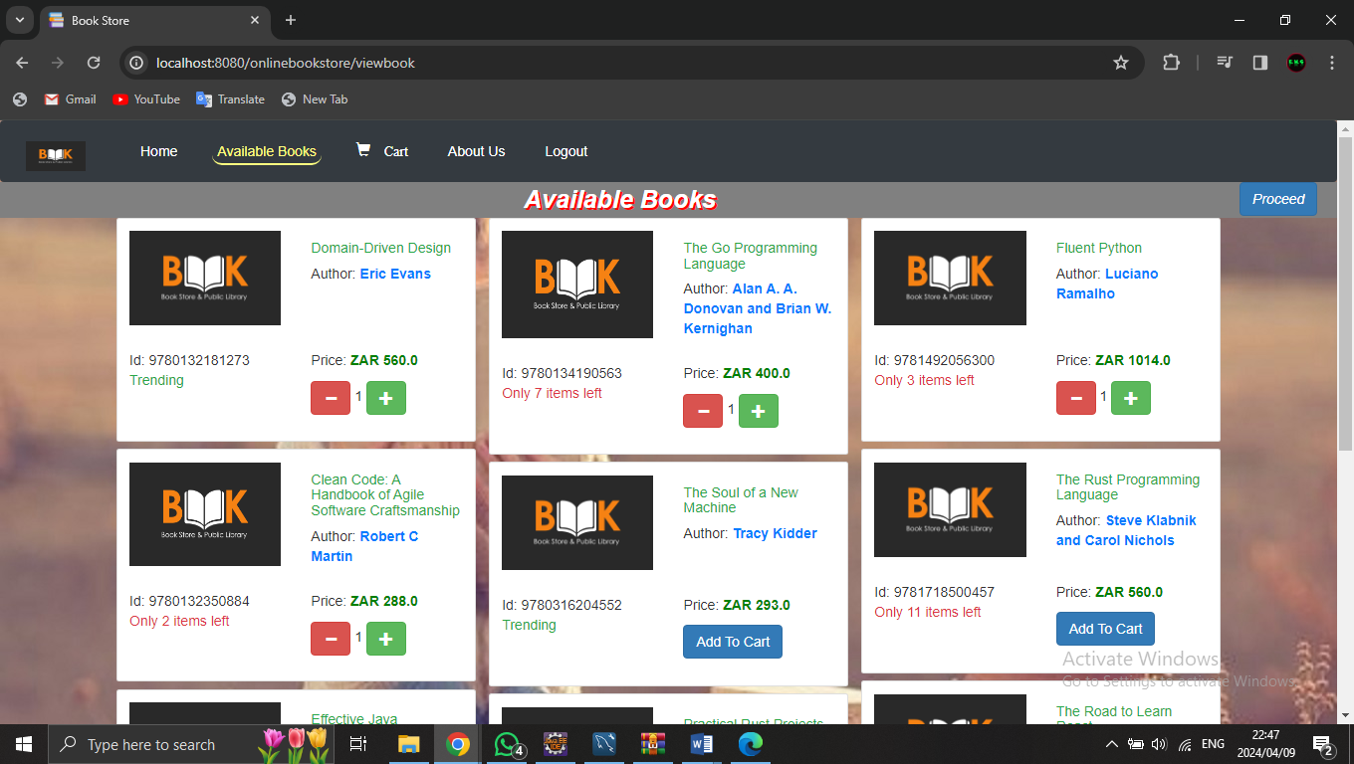
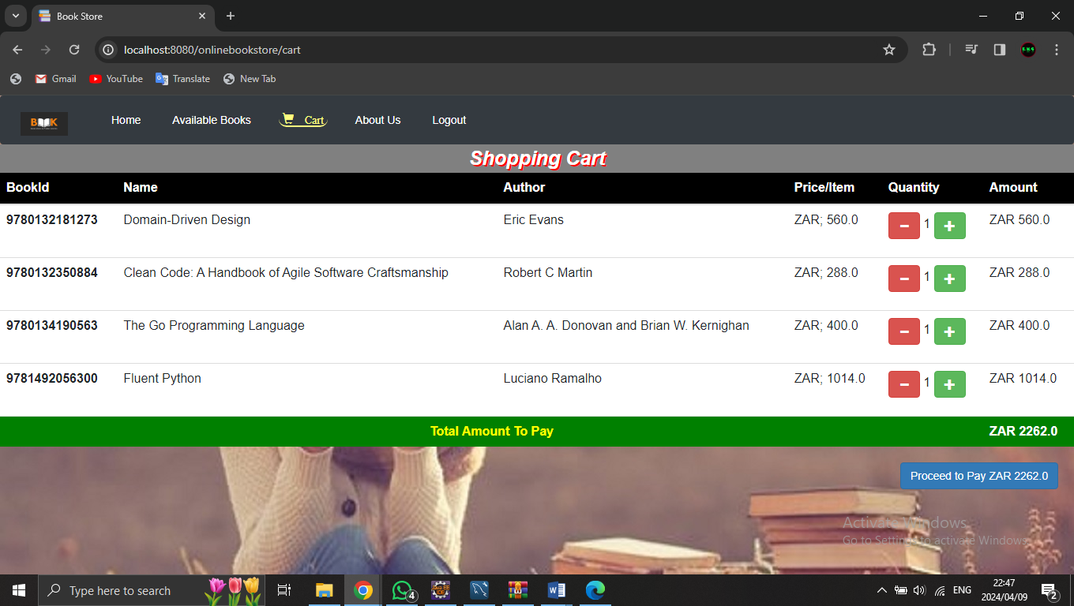
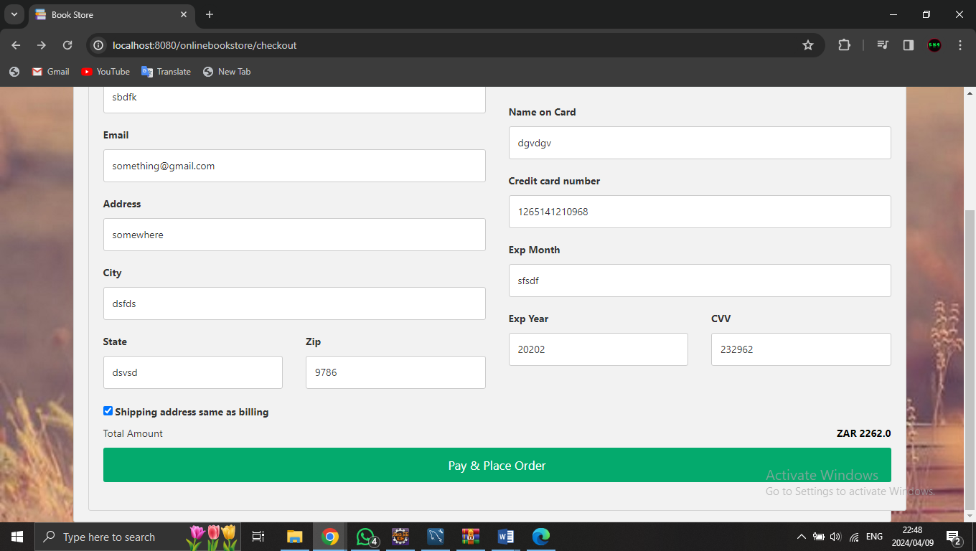

- What to do when logged in as ADMIN
- Click on store books to see the BOOKS and the quantity of each books.
- If you wish to add book Click on ADD BOOKS and fill in the details, and then click on ADD BOOK button. Like that your book will be added to the list.
- If you wish to remove an book Click on remove book ion the Nav Bar before that COPY the ID number of the book you wish to remove then paste the ID number and then you can Click on the Remove button like that the Selected book is removed.
- Then you can LOGOUT.
